(4X)(4X)

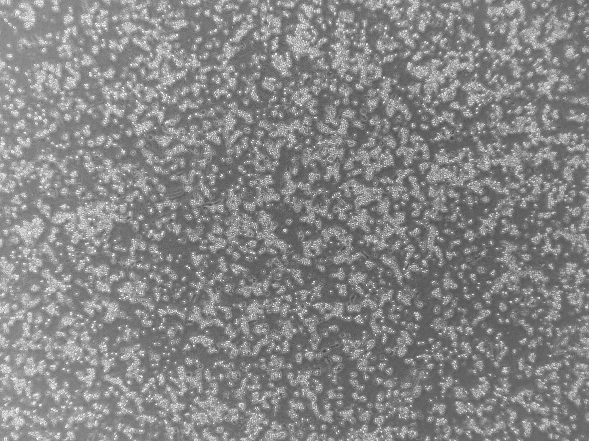

Figure6-3 Control group after 72h Figure6-4 PMA group after 72h

(20X)(20X)

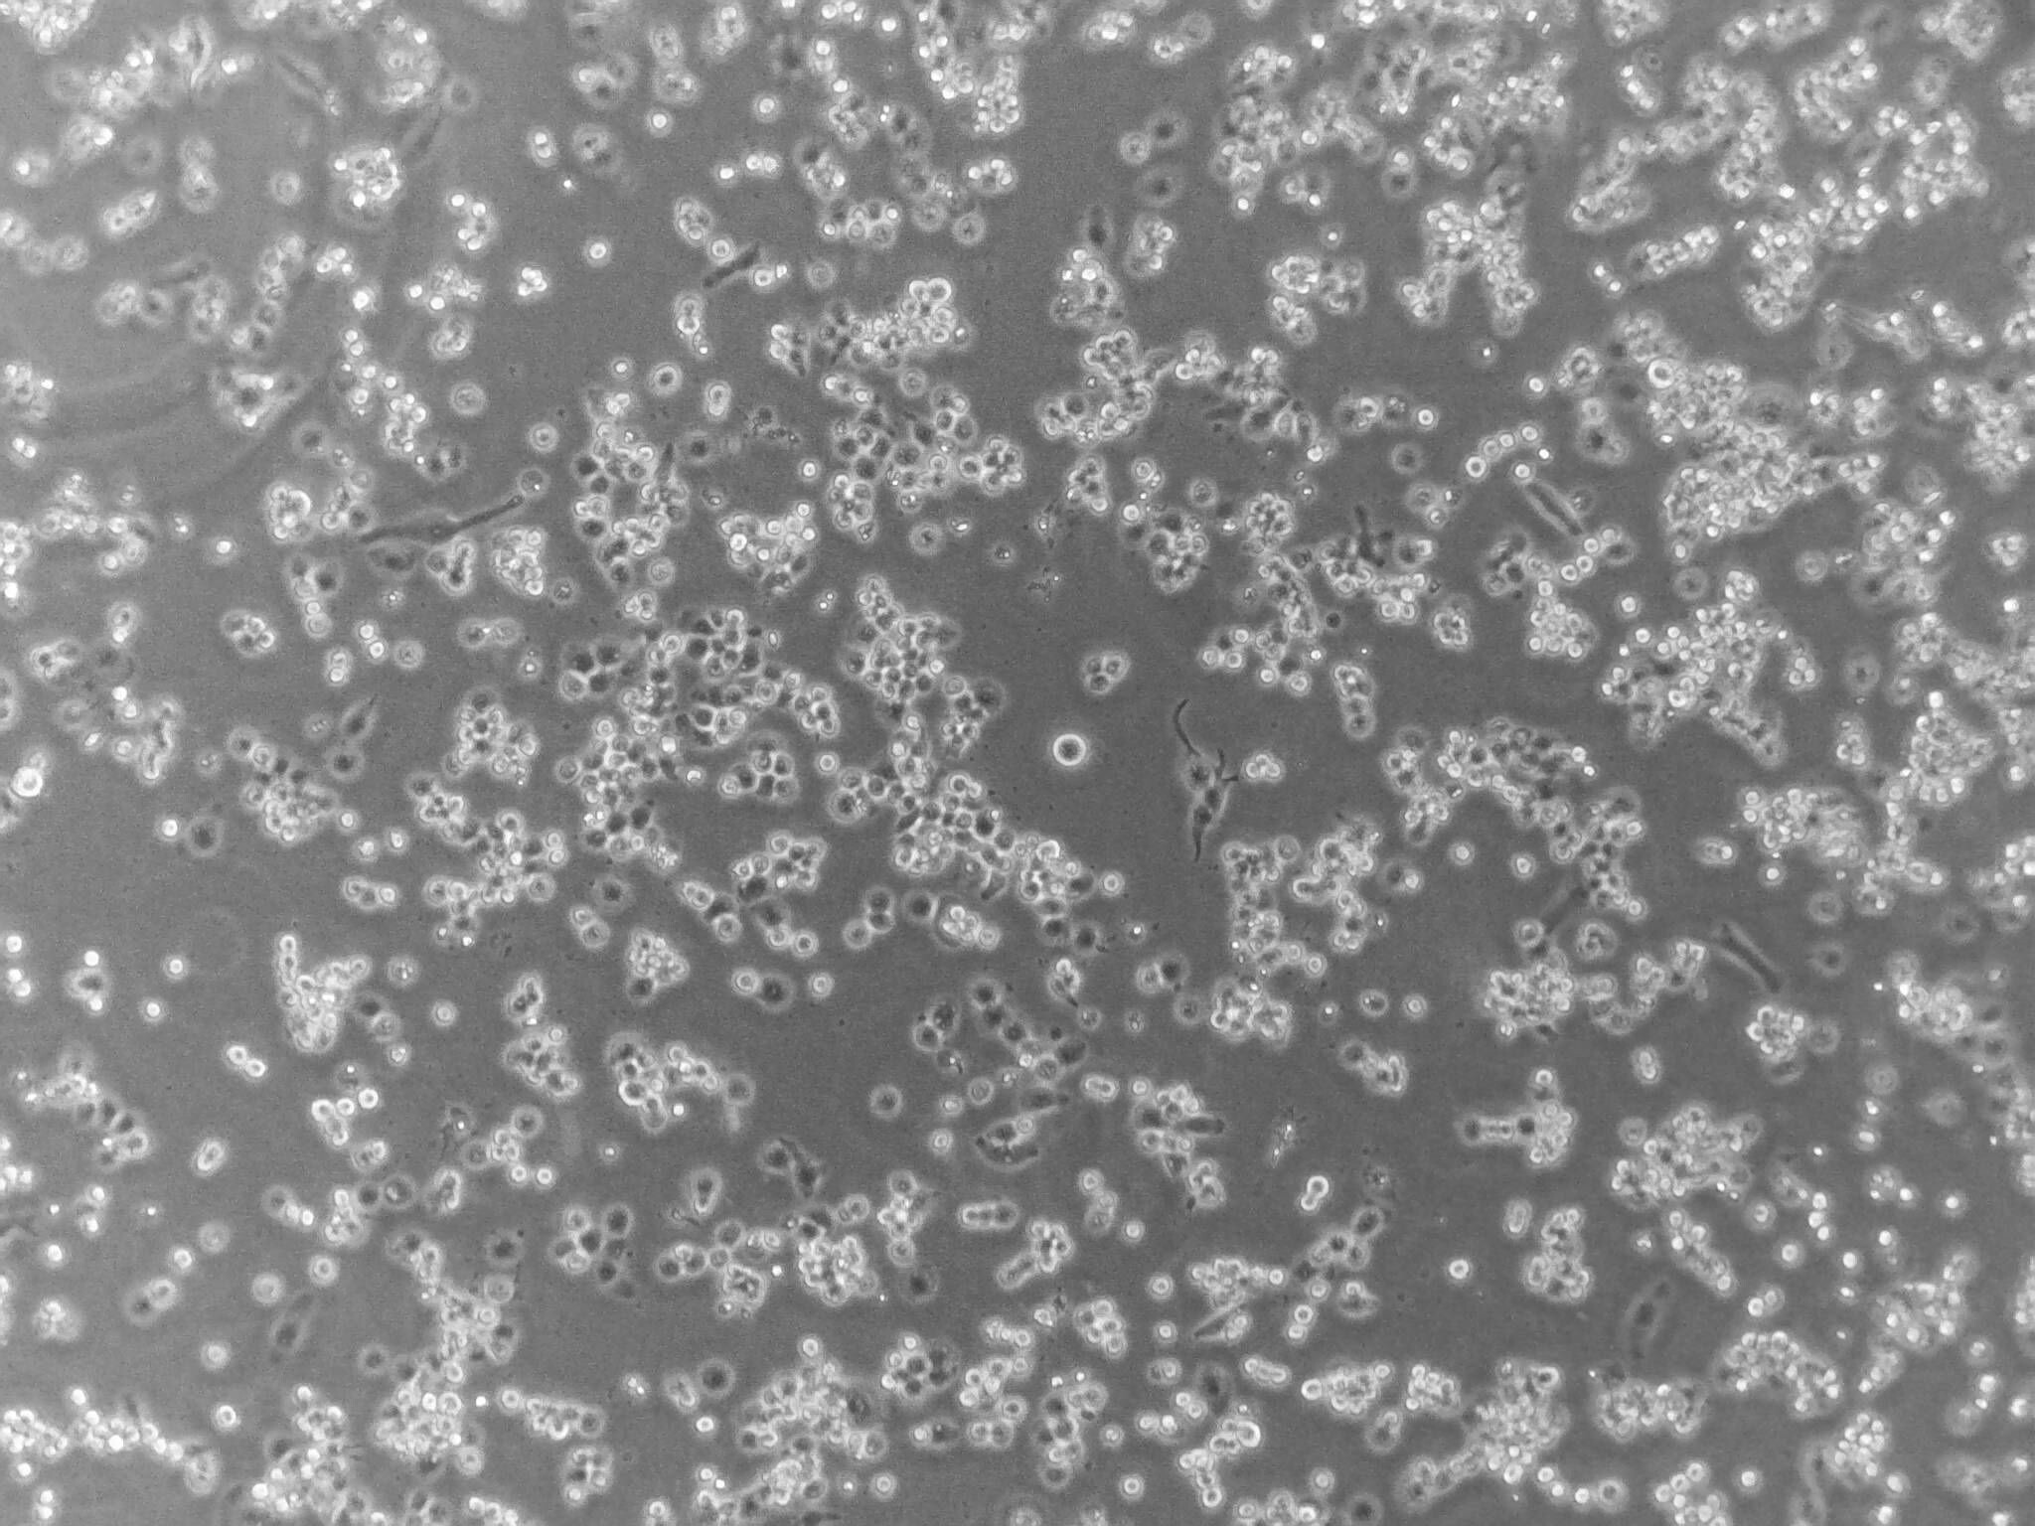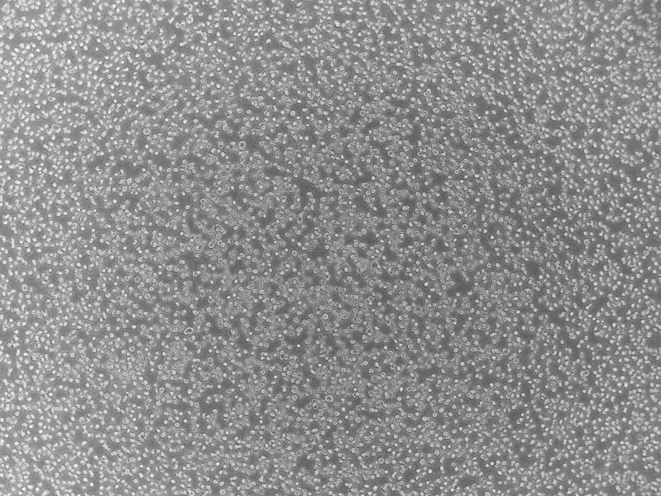

Figure6-5 PMA group after 72h Figure6-6 Control group after 72h

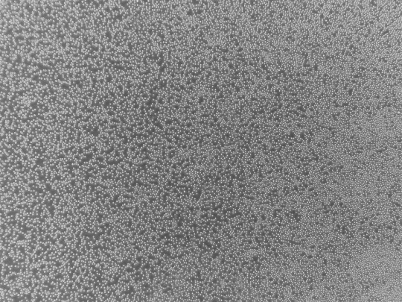(4X)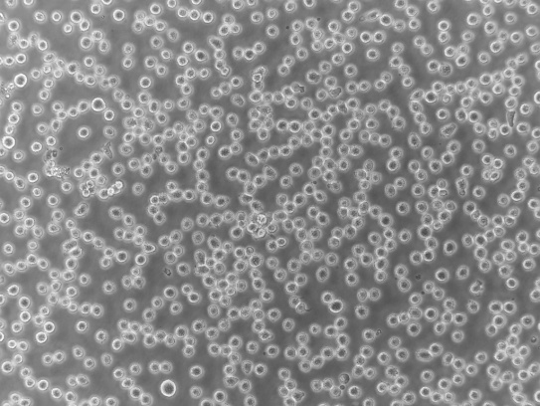(20X)

Figure6-7 Control group after 24h Figure6-8 Control group after 24h

(4X)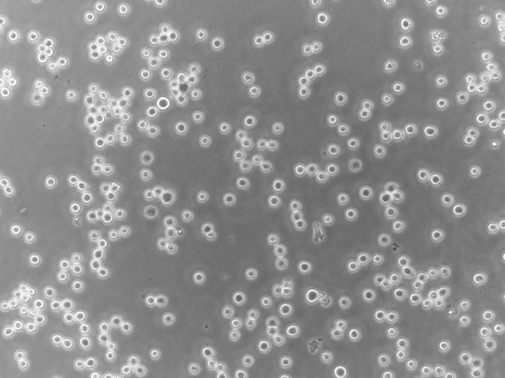(20X)

Figure6-9 PMA group after 24h Figure6-10 PMA group after 24h

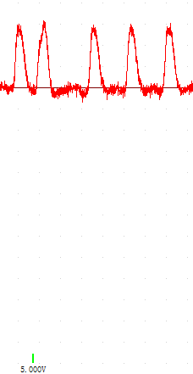

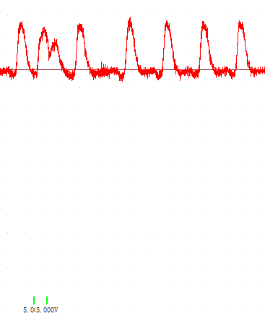

Figure6-1 Figure6-2

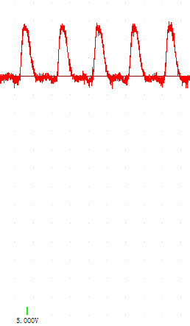

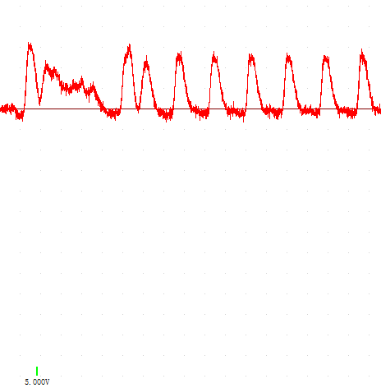





Figure6-3 Figure6-4

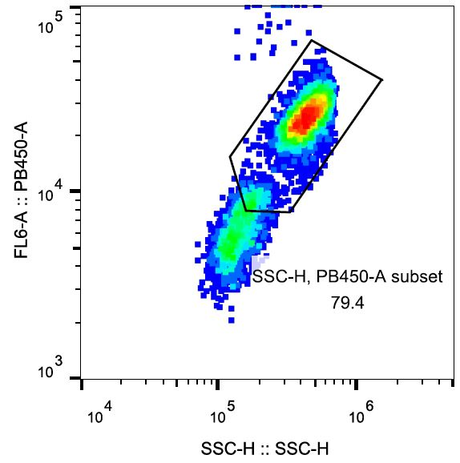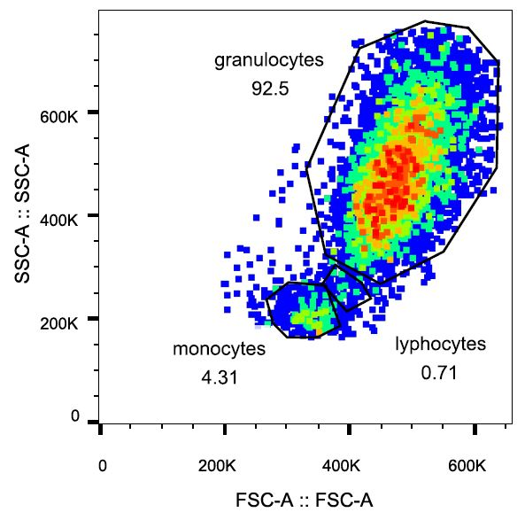

Figure6-1 FASC analysis of white blood cell Figure6-2 FASC analysis of white blood cell